目 录
Instructions for Accessing Waybill Details
Integrate the JointCloud Monitoring Module
Instructions for Accessing Waybill Details

Process Introduction
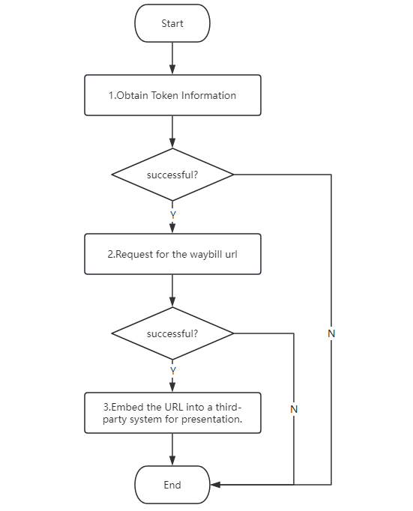

Docking Instructions

Interface Request Address:
Test Environment Address: http://120.25.245.20:8092/OpenApi
Production Environment Address (Mainland China): https://cloud.assetscontrols.com:3443/OpenApi
Production Environment Address (Hong Kong, China): https://icloud.assetscontrols.com:3443/OpenApi
Production Environment Address (Cairo): https://kcloud.assetscontrols.com:3443/OpenApi

Request Method:
POST

Request Header:
Parameter Name | Required | Type | Description
Content-Type | Yes | string | Request type: application/json

1.Obtain Token Information
The token obtained by the same user is a fixed value. It is recommended to cache the token and there is no need to request it repeatedly.

Request Path: /login
Test Environment Address: http://120.25.245.20:8092/OpenApi/login
Production Environment Address (Mainland China): https://cloud.assetscontrols.com:3443/OpenApi/login
Production Environment Address (Hong Kong, China): https://icloud.assetscontrols.com:3443/OpenApi/login
Production Environment Address (Cairo): https://kcloud.assetscontrols.com:3443/OpenApi/login

Request Parameters:
Parameter Name | Required | Type | Description
FUserName | Yes | string | User name
FPassword | Yes | string | Password (MD5(32))

Return Example:
When correct, the return is:
{
"Result"
:
200
,
"Message"
:
"success"
,
"FObject"
: [{
"FUserName"
:
"admin"
,
"FUserGUID"
:
"63C399BD-2A0B-40E9-857D-6DEBF4908F92"
,
"FTokenID"
:
"DB7F20D9-84C3-44C3-B05A-06A9C392A189"
,
"FExpireTime"
:
"2020-07-30T08:00:00"
}]
}
When incorrect, the return is:
{
"Result"
:
103
,
"Message"
:
"userName or password is error"
,
"FObject"
:
null
}

Explanation of Returned Parameters:
Parameter Name | Type | Description
FUserName | String | User name
FUserGUID | String | Unique user identifier
FTokenID | String | Unique identity identifier (this is required for identity verification in all subsequent interface requests)
FExpireTime | DateTime | Account expiration time (UTC time. Add 8 hours to convert it to Beijing time)

Remarks:
More return error codes are as follows:
106: Account expired
103: Incorrect user name or password
102: Incorrect request parameters

Postman Request Example:
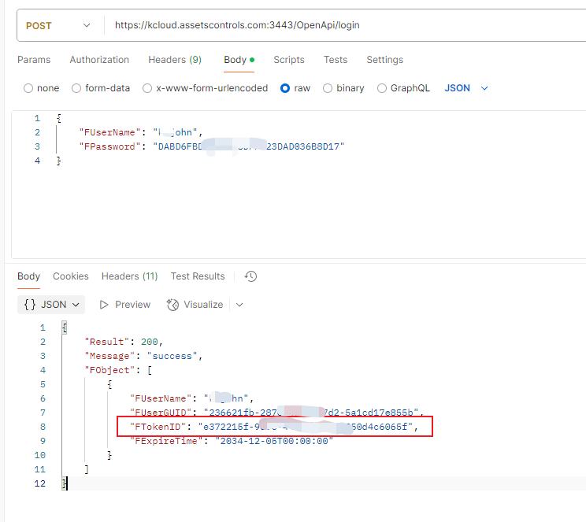

2.Request for the waybill url
The request interface will match the waybills that meet the conditions based on the waybill number and the relevant information. If the matching is successful, it will return the link to the waybill details. Otherwise, it will return empty information.

Request Path: /KLRoute
Test Environment Address: http://120.25.245.20:8092/OpenApi/KLRoute
Production Environment Address (Mainland China): https://cloud.assetscontrols.com:3443/OpenApi/KLRoute
Production Environment Address (Hong Kong, China): https://icloud.assetscontrols.com:3443/OpenApi/KLRoute
Production Environment Address (Cairo): https://kcloud.assetscontrols.com:3443/OpenApi/KLRoute

Request Parameters:
Parameter Name | Required | Type | Description
FAction | Yes | string | QueryLastingDepartureInfoWithFrame (fixed value)
FTokenID | Yes | string | Authentication information
FAssetID | Yes | string | Device number
FWaybill | Yes | string | Waybill number
FTimeDifferent | Yes | int | Time difference (in minutes)
FLanguage | Yes | int | Language. 0 for English, 1 for Chinese

Return Example:
When correct, the return is:
{
"Result"
:
200
,
"Message"
:
"check token success"
,
"FObject"
:
"https://xxx.assetscontrols.com:2443/fxydindex.html#/?480&xxx&10&isIframe"
}
When no result is found, the return is:
{
"Result"
:
200
,
"Message"
:
"check token success"
,
"FObject"
: []
}
When incorrect, the return is:
{
"Result"
:
102
,
"Message"
:
"parameters(FTokenID/FAction) are error"
,
"FObject"
: []
}

Explanation of Returned Parameters:
Parameter Name | Type | Description
FObject | String | URL address

Remarks:
More return error codes are as follows:
102: Incorrect request parameters

Postman Request Example:
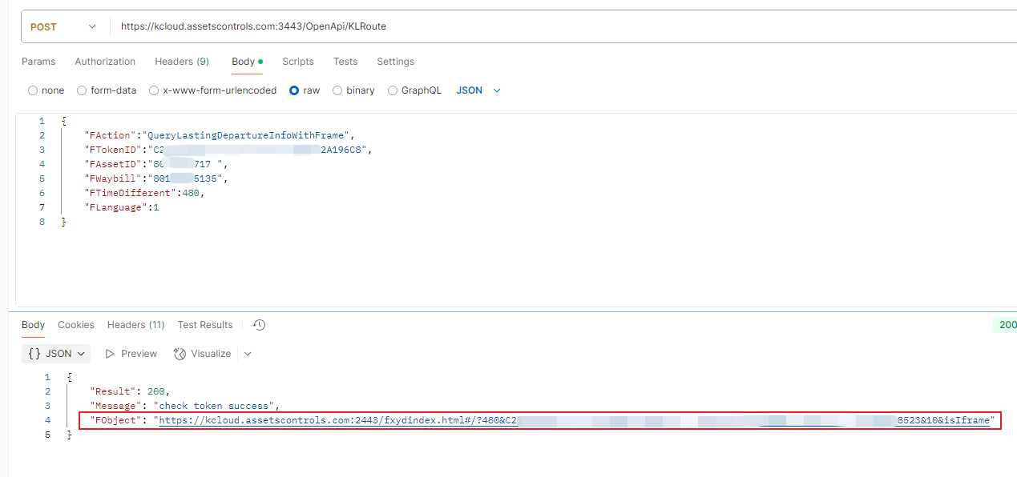

3.Embed the URL into a third-party system for presentation.
Just assign the obtained URL to the src attribute of the iframe tag in the system to be embedded.
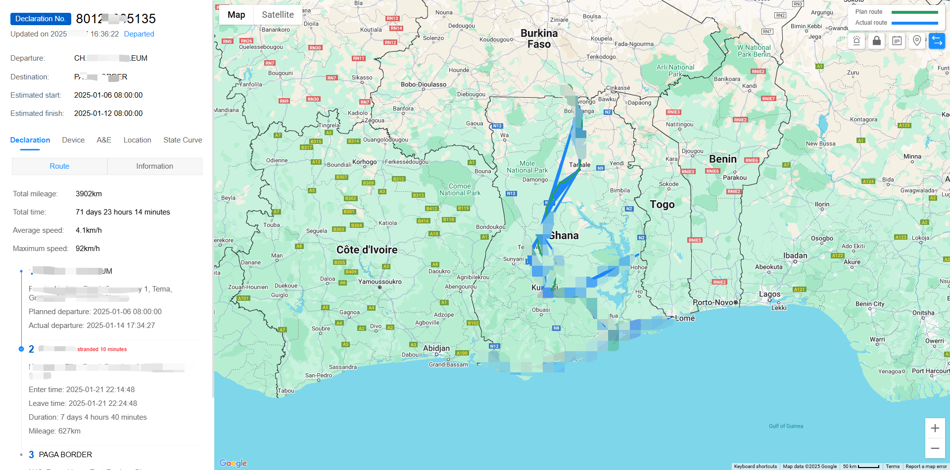

Integrate the JointCloud Monitoring Module

Process Introduction
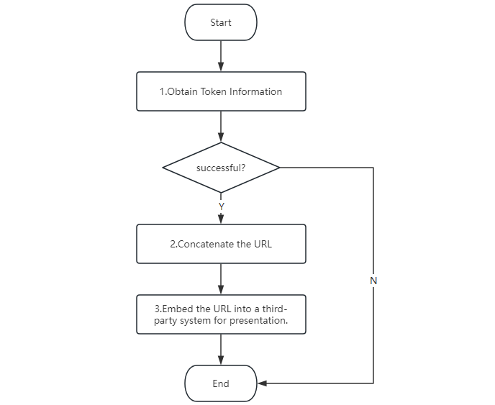

Docking Instructions

Interface Request Address:
Test Environment Address: http://120.25.245.20:8092/OpenApi
Production Environment Address (Mainland China): https://cloud.assetscontrols.com:3443/OpenApi
Production Environment Address (Hong Kong, China): https://icloud.assetscontrols.com:3443/OpenApi
Production Environment Address (Cairo): https://kcloud.assetscontrols.com:3443/OpenApi

Request Method:
POST

Request Header:
Parameter Name | Required | Type | Description
Content-Type | Yes | string | Request type: application/json

1.Obtain Token Information
The token obtained by the same user is a fixed value. It is recommended to cache the token and there is no need to request it repeatedly.

Request Path: /login
Test Environment Address: http://120.25.245.20:8092/OpenApi/login
Production Environment Address (Mainland China): https://cloud.assetscontrols.com:3443/OpenApi/login
Production Environment Address (Hong Kong, China): https://icloud.assetscontrols.com:3443/OpenApi/login
Production Environment Address (Cairo): https://kcloud.assetscontrols.com:3443/OpenApi/login

Request Parameters:
Parameter Name | Required | Type | Description
FUserName | Yes | string | User name
FPassword | Yes | string | Password (MD5(32))

Return Example:
When correct, the return is:
{
"Result"
:
200
,
"Message"
:
"success"
,
"FObject"
: [{
"FUserName"
:
"admin"
,
"FUserGUID"
:
"63C399BD-2A0B-40E9-857D-6DEBF4908F92"
,
"FTokenID"
:
"DB7F20D9-84C3-44C3-B05A-06A9C392A189"
,
"FExpireTime"
:
"2020-07-30T08:00:00"
}]
}
When incorrect, the return is:
{
"Result"
:
103
,
"Message"
:
"userName or password is error"
,
"FObject"
:
null
}

Explanation of Returned Parameters:
Parameter Name | Type | Description
FUserName | String | User name
FUserGUID | String | Unique user identifier
FTokenID | String | Unique identity identifier (this is required for identity verification in all subsequent interface requests)
FExpireTime | DateTime | Account expiration time (UTC time. Add 8 hours to convert it to Beijing time)

Remarks:
More return error codes are as follows:
106: Account expired
103: Incorrect user name or password
102: Incorrect request parameters

Postman Request Example:

2.Concatenate the URL
Concatenate the URL according to the access environment
Access Environment Address:
Test Environment Address: http://120.25.245.20:8081/
Production Environment Address (Mainland China): https://cloud.assetscontrols.com:2443/
Production Environment Address (Hong Kong, China): https://icloud.assetscontrols.com:2443/
Production Environment Address (Cairo): https://kcloud.assetscontrols.com:2443/

javascript example
// Authentication information obtained from the above interface
const
authInfo = FObject[
0
];
// Specify the system language as English
authInfo.FLanguage =
'en'
;
// Concatenate the address
// isIframe=1 is a fixed parameter, indicating that the current link is for embedding.
// iframeRouteCode=11 means the embedded page is real - time monitoring, and iframeRouteCode=12 means the embedded page is trajectory playback.
// params is the encoded authentication information
const
jtCloudUrl =
`https://xxx.assetscontrols.com:2443/?isIframe=1&iframeRouteCode=11&params=
${
encodeURIComponent
(
JSON
.stringify(authInfo))}
`
;

3.Embed the URL into a third-party system for presentation.
You just need to assign the obtained URL to the src attribute of the iframe tag in the system to be embedded.
iframeRouteCode=11 corresponds to real-time monitoring.
http://120.25.245.20:8081/?isIframe=1&iframeRouteCode=11&params=%7B%22FUserName%22%3A%22jtrj%22%2C%22FUserGUID%22%3A%2275c43ea6-017a-4102-a83e-8f6329946b40%22%2C%22FTokenID%22%3A%22ec51d691-d9a7-4f74-95a8-1856be2ae745%22%2C%22FExpireTime%22%3A%222033-08-31T00%3A00%3A00%22%7D
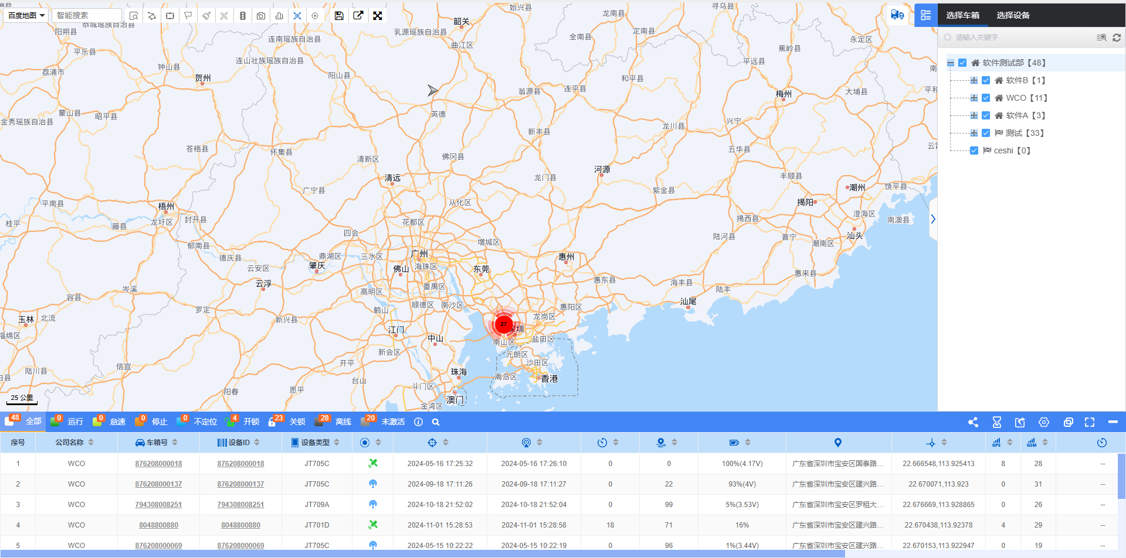
iframeRouteCode=12 corresponds to trajectory playback.
http://120.25.245.20:8081/?isIframe=1&iframeRouteCode=12&params=%7B%22FUserName%22%3A%22jtrj%22%2C%22FUserGUID%22%3A%2275c43ea6-017a-4102-a83e-8f6329946b40%22%2C%22FTokenID%22%3A%22ec51d691-d9a7-4f74-95a8-1856be2ae745%22%2C%22FExpireTime%22%3A%222033-08-31T00%3A00%3A00%22%7D


